LELLE: Let's learn how to learn! - Raising awareness to the importance of and providing an innovative solution for the inclusion of the training of learning skills in existing higher education curricula

MENTOR TRAINING MATERIAL
2015-1-HU01-KA203-013619

Date: March 2017

Version: 5
Prepared by: BEST Institut für berufsbezogene Weiterbildung und Personaltraining GmbH, Austria

Open Universiteit, The Netherlands
Table of Contents

1. Introduction to LELLE 3
2. The Profiling Concept Structure 7
3. Methods for Core Skills Development and Evaluation 9
3.1 Methods to Develop Core Skills 15
3.2 Methods to Evaluate Core Skills 17
3.3 Implementation examples “Critical Thinking” 19
3.4 Implementation examples “Problem Solving” 27
3.5 Implementation examples “Managing own learning process” 34
4. Profiling criteria 40
5. Appendices 50
Appendix 0: HANDOUT - Summary of IO1 Methods to Develop / Evaluate Core Skills 51
Appendix 1: Critical Thinking Skill-Set 54
Appendix 2: Decision-making Case Scenario 55
Appendix 3: Public Health Case Scenario 56
Appendix 4: The Scientist 57
Appendix 5: The Professor 58
Appendix 6: Critical Thinking Scoring Rubric 60
Appendix 7: Seven Steps in Problem Solving 62
Appendix 8: The Deli Dilemma 63
Appendix 9: Teamwork Skills Self Inventory 64
Appendix 10: Problem Solving Organiser 65
Appendix 11: Problem Solving Scenario I 66
Appendix 12: Problem Solving Scenario II 67
Appendix 13: Problem Solving Scoring Rubric 69
Appendix 14: My Learning Portfolio 71
Appendix 15: Reflecting Questions 72
Appendix 16: Template for own notes on implementation of methods in your organisation 74
Appendix 17: Template for own notes on implementation of methods in your organisation 75
Appendix 18: Template for own implementation activity 76
Appendix 19: Short user manual of LELLE profiling tool for students 78
Appendix 20: Most often mentioned learning methods found during the project research phase 79
6. References 80

1. Introduction to LELLE
With increasingly rapid changes in the work place, in part due to changing technology and as a result of changing societal needs in the context of globalization, citizens must learn to learn – being one of the key competences the European Commission has defined.
Learning to learn is the ability to pursue and persist in learning, to organise one’s own learning, including through effective management of time and information, both individually and in groups. This competence includes awareness of one’s learning process and needs, identifying available opportunities, and the ability to overcome obstacles in order to learn successfully. This competence means gaining, processing and assimilating new knowledge and skills as well as seeking and making use of guidance. Learning to learn engages learners to build on prior learning and life experiences in order to use and apply knowledge and skills in a variety of contexts: at home, at work, in education and training. Motivation and confidence are crucial to an individual’s competence.
The project – “Let's learn how to learn! - Raising awareness to the importance of and providing an innovative solution for the inclusion of the training of learning skills in existing higher education curricula” (Acronym: LELLE) – wants to see the soft skills training built into curricula of Higher Education Institutions (HEIs) across Europe and to provide a working solution to acquiring the skill Learning to Learn:

Initially, the LELLE survey on BEST PRACTICES IN EVALUATING AND DEVELOPING THE LEARNING COMPETENCE was conducted in 2016 amidst training providers and company representatives welcoming HE students Europe-wide and particularly in the partner countries Austria, Hungary, the Netherlands and Poland. After in-depth desktop and literature research as well as internal discussions, the LELLE consortium has decided in consensus to base the overarching competence "learning to learn" on the three core skill-sets: Critical Thinking, Problem Solving and Management own Learning Processes. These three core skill-sets together with their respective subsets (see figure 2, p.8) were identified as critical for learners in general and in particular graduates to enter the workforce. The following chapters will give further details on these skills sets, as well as on suggested education activities in HE for their implementation in daily teaching practice.
Since both, educators as well as their learners are concerned when: “The teaching professions now face rapidly changing demands, which require a new set of competences.”, it is even of more importance to also support teaching staff as “Teachers are the key to improving the performance of learners...” - or at least one important corner stone to it. However, in many Member States, competences teaching staff shall have are still not yet defined by their governments for all education levels ; and Cedefop highlights in a briefing note that teachers need “(…) not only the right knowledge and skills, but also the appropriate attitudes to bring about curriculum change”. In line, the respondents to the LELLE survey highlighted the need to develop the Learning to Learn competence not only in people being educated but also in educators, as well as administrative and technical employees due to the fact that universities, higher schools or providers of lower formal education levels form an extremely complex and changeable environment.
It is for these reasons that the LELLE project has foreseen a LELLE Mentor Training aimed at fostering the implementation of the Learning to Learn Competence into HEi curricula. First, mentors (LELLE partners and ‘trainers’ for further mentors) are addressed. Suggested requirements are:
- They shall have an accomplished pedagogical education (teacher training, trainer/coach education, educational training/study, or equivalent),
- experience in teaching/coaching/training from previous work,
- Experience with Lifelong learning (LLL) in the context of work and experience with LLL in his/her personal life.
In the future, they shall support and mentor teachers in different subjects at universities in implementing selected methods for the development and evaluation of LELLE core skills into 1st study years’ curricula with the final objective to better help students related to their employability.
This training is structured for the duration of two training days and can be adapted as tailor—made course according to the participants’ specific prior knowledge and competences thanks to a modular approach of the respective training material:
LELLE Mentor Training - Agenda
Duration (appr.) | Training Content
15 min | - Introduction to LELLE  What is & Why the need for LELLE?
15 min | - The Profiling Concept Structure  What core skills are considered?
15 min | - Methods to Develop Core Skills and to Evaluate Core Skills
 | How mentors can support students and lecturers to master the competences of Critical Thinking, Problem Solving, Managing Own Learning Process
210 min | - Critical Thinking  Hands-on Session: Critical Thinking Skills  Objective: To critically evaluate ideas, identify connections and recognise opportunities to make sound decisions
210 min | 3.4 Problem Solving  Hands-on Session: Problem Solving  Objective: To analyse and evaluate problem by posing questions, identify problem and possible solutions, make decisions and justify solutions.
200 min | 3.5 Managing One’s Own Learning Process  Hands-on Session: Management of Own Learning Process  Objectives: To process new information according to individual needs, to set learning goals and find ways to reach them, to strategically plan and implement learning processes considering time, effort and outcome.
 | - Profiling Criteria
15 min | 4.1 Presentation of the Online Self-Assessment Tool  How does it work, what does it show, which tasks do mentors have, what do students have to do and what will they receive as output from the tool?
30 min | 4.2 Practical Application and Reflection  Individual use of the online Tool and following reflection about practical application
30 min | - Open Issues and Final Discussion
Figure 1: LELLE Mentor Training - Agenda

The present LELLE Mentor Training material forms part of the LELLE Kit, a ready-to-use package of various materials that can be applied anywhere in Europe for the implementation of Learning to Learn competence improvement into HE curricula. The following chapters give insight into
- the Profiling Concept Structure (chapter 2) to know the selected learning skills, to then provide
- Methods for Core Skills Development and Evaluation with Implementation examples for the three skills clusters (chapter 3) to know how to include selected methods in HE curricula, as well as the introduction to
- the Profiling criteria (self-assessment tool) introduction (chapter 4) to help inform on the online use of the tool.
- Appendices offer hand-outs and templates as well as links the (in this document version) provisional list of methods collated during the LELLE survey.
In this document, the material for Critical Thinking and Problem Solving were developed by Open University in the Netherlands and BEST Institut für berufsbezogene Weiterbildung und Personaltraining GmbH, Austria, developed all other details in this document.

The LELLE partnership is formed by:
University of Pannonia, Faculty of Business and Economics, HU
Wrocław University of Economics, PL
BEST Institut für berufsbezogene Weiterbildung und Personaltraining GmbH, AT

The Open University of the Netherlands, NL

Europa Consortium Regional Development Non-profit Ltd., HU

Find more details about the project and its partners here:
Web: http://lelle.gtk.uni-pannon.hu
www.facebook.com/lelleproject
www.linkedin.com/groups/8537515

2. The Profiling Concept Structure
Assessing learning skills of students entering higher education with the help of a filter system “Profiling criteria” for then specifically teaching the missing skills through learning skills development built into HE curricula are key considerations in – and outcomes of - the LELLE project. For this, the project partnership organised spring to summer 2016 the LELLE survey collating BEST PRACTICES IN EVALUATING AND DEVELOPING THE LEARNING COMPETENCE from education industry and hiring organisations that served as basis for the present profiling concept structure.
The aforementioned three skills clusters settled in the Learning to Learn competence, i.e. Critical thinking, Problem Solving and Managing own Learning Processes, were considered. Opinions of employees from HE institutions, adult educate providers as well as employers (and their HR departments) in Europe and outside mentioned in the LELLE survey the following being important in particularly within:
- Critical Thinking – to reflect and handle tasks autonomously; to make sound decisions and reasonable judgements; to identify connections and recognize opportunities; critically evaluate ideas.
- Problem Solving – to understand the process of successful problem-solving; to be able to solve problems independently and collaboratively; a mixture of analytical and creative thinking; assertive, open communication.
- Managing own Learning Processes – strategy, training, time management; the ability to access, gain, process and assimilate new knowledge and skills, organise their own learning, evaluate their own work; integrating information into the learning process in appropriate ways, adjusting way of learning to own goals.

Taking their prompts further, the three (3) core skills were sub-divided into further four (4) key aspects that are then also considered in the learning assessment as well as the implementation of education activities of methods for the core skills development and evaluation. The following graph gives this overview:

Figure 2: LELLE Profiling Concept Structure

As aforementioned, a filter system “Profiling criteria” (c.f. chapter 4) has been elaborated in the LELLE project to offer students (in their first study year) a self-assessment based on the above shown structure. This self-assessment is available as online tool. (http://kerdoiv.gtk.uni-pannon.hu/index.php/921421?lang=en)

3. Methods for Core Skills Development and Evaluation
A report from working groups researching the situation in EU Member States’ education systems related to Key Competences formed on behalf of the Education and Training Programme 2010 summarised in 2007 that “(…) key competences do indeed have a high status in Member States' lifelong learning strategies. Similarly, they are either explicitly or implicitly in European school curricula; but their implementation requires a major change in teaching practice.”
The educational institutions that participated in the LELLE survey confirm this importance: the Learning (to Learn) competence is perceived as the key competence in life that allows to act in an efficient manner and to achieve set goals. This was perceived as even more valid since nowadays’ Western labour markets increasingly ask for an acquisition of specific knowledge more often than once, for ongoing learning of new facts, keeping gaining new experiences and continuously assessing them, making the learning skill simply essential for this progress and development.
The partnership collated from survey participants their practices in education and in the general labour market targeting the development and evaluation of the selected core skills. From the multitude of prompts delivered in the LELLE survey, some have been used to provide example implementation activities that can help mentors design and work out further activities tailoring the LELLE Mentor Training further to their specific situation.
Critical thinking
All respondents identified critical thinking as one of the key competences necessary for the (academic) career. This skill is built in and encouraged in the performance system in organisations that participated in the LELLE survey. There were methods mentioned to be used in everyday life for employees to practice and implement critical thinking such as: Lean process, lost hunting, assertive communication, idea boy, coaches and trainings. Fact is, that each interviewee defined critical thinking in a similar way but suggested to apply different methodology for triggering and practice. The skill is also perceived as crucial for planning and carrying out of project tasks.

Problem solving
Some representatives of the participating organisations could not really separate critical thinking from problem solving, other interviewees only could after having been reminded to try a separate definition. They mentioned problem solving techniques, such as 5S, KAIZEN, standardised and ad-hoc problem, problem-analysis-solution-feedback cycle. An attitude towards problem solving was emphasised as the most important aspect to develop.
Managing own learning process
LELLE survey participants felt this to be the skill that was not so easily defined, being more diverse at first, but then nearly all interviewees linked this to their existing career or individual development plan, training academy where colleagues could learn from one another, or the presentation in the performance system. They all thought that managing one’s own learning path has something to do with work-life balance, lifelong learning and career goals. In this competence, they included time management skills, self-knowledge and reflective mind-set.
In general, for the implementation of any method the previously mentioned Key Competence working groups highlighted an ideal learning environment for the key competences obeyed a holistic approach including, inter alia, the following elements that consider pedagogic, organisational and communicational aspects:
- Active learning and experimental learner-centred teaching;
- Qualitative Management of subjects and cross-curricular elements;
- Joint understanding of key skills development support available and of necessity in any new ones per subject
- Infrastructure and time for effective collaboration (to all concerned parties);
- Appropriate assessments (for learners, teaching staff and the whole system).

Even if in some project partner countries (e.g. the Netherlands and Austria) a cross-curricular teaching approach, exchange among teaching staff and assessment measures may have been implemented (here and there), in neither of the partner countries this has been done in good coordination with future work-place requirements in respect of the Learning to Learn competence nor at all education levels and curricula. The LELLE project therefore wants to support the implementation of learning to learn competence across HE subjects and curricula in line with the EDUCATION AND TRAINING 2010 WORK PROGRAMME:
A successful implementation of a curricula based on key competences is not in contradiction with subjects that can allow for a development of in -depth knowledge of a certain discipline and target the acquisition of specific skills. However, if the focus is on the development of a full range of key competences for lifelong learning, subject knowledge should be seen rather as a first step that alone is not sufficient to fully respond to the needs of a learner in a modern society.
The challenge is thus the systematic use of subject matter and the specific skills related to subjects as essential elements of the development of key competences. This requires all teachers, irrespective their subject specialisation, to be aware of and responsible for, developing the key competences of their students in the whole school context.

The following overview provides collated best practices on the verification of learning competence in general, Critical Thinking, Problem Solving and Managing own learning process from LELLE survey participants. The table separates the details according to the answers given by formal, non-formal education providers and other organisations (i.e. general employers). A template in the appendices offers room for your own notes.

 |  | Learning Competence in general | Critical Thinking | Problem Solving | Managing own learning process
Universities, schools of the so-called formal education
 | Documents: CV, letter of application, references  Recruitment interview | various tools/instrument to assess competencies, including Rickter model (model of assessing and developing soft skills),  Tuning list (list of 31 competencies that can be assessed in one day) or  Gallup Institute’s talent test – Strengths Finder, which evaluates if learning is one of the five key talents.  Role plays, case study analysis  Initial assessment or trainings periodic evaluation systems for academics,  Class inspections by superiors, student surveys  Students’ competencies are verified during classes based on periodic subject and diploma exams, final exams, tests, interim papers, projects, essays, research results. | assessment of course and outcomes of tasks performed  control works and exams  publications of academic works in good and very good academic magazines  obtaining academic title in a specific period  periodic assessment of academic and inspections  feedback questionnaires to students  results of organizational works | during classes: looking for and presenting possible problem solutions, tasks allowing to improve this skill  effectiveness of decisions made/ solutions found  observing employees and actions taken  task team meetings – exchanging experiences solution finding  periodic employee assessment  number and quality of publications | assessment of “life successes”, results and course of professional career  assessment of quality and regularity of performed tasks  assessment of state of gained knowledge  active search for/ participation in forms of professional development (e.g. as workshops, training, courses etc.)  interviews and observations  exams (students and pupils)
 |  | Learning Competence in general | Critical Thinking | Problem Solving | Managing own learning process
TRAINING INSTITUTIONS (language and coaching schools, continuing education centres, etc.) of non-formal education
 | Prove of achievements in education (academics) and of practical use of knowledge, skills and competencies.  Competence/diagnostic tests, including solving practical tasks related to a specific position  entrance exams for studies | familiarisation with course of professional work/ tasks completed, qualifications and references presented  Document analysis - what qualifications the candidate has, when he or she obtained them or if they are updated.periodic evaluation based on competence profiles with questionnaires, diagnostic tests  employing for trial period with observation, educational class inspections, talking before and after such inspections  take part in projects with feedback | assessment of written works sometimes used for training participants  critical thinking verified in discussions  Competence Assessment rarely used for employees | observations and monitoring of work  assessment interviews, feedback of trainees  finding new solutions that are good on the market  use of solutions in practice/ implementation of suggested improvements  problem discussions – the ability to communicate efficiently, draw conclusions from experiences, suggest solutions, plan and predict consequences of actions  consulting projects in companies | assessment of current academic and business achievements  applying for trainings  assessment of employee initiative in gaining/ updating knowledge
 |  | Learning Competence in general | Critical Thinking | Problem Solving | Managing own learning process
NON-EDUCATIONAL ORGANIZATIONS (companies, workplaces – “employers”)
 | (Behavioural) interviews  Various competence tests are used.  specific tasks to perform. | Their ability and quickness to achieve the goal are assessed. Not only is the result itself important but also the way of achieving the solution (assessment of the way of thinking).most frequently periodic evaluation based on competence profiles | employee feedback  feedback from supervisor on work | observation of employees doing professional tasks  indicating weaknesses and strengths | results of customer cooperation  proposals to solve issues in a „non-standard” way  individual initiative to increase scope of own knowledge, participation in various forms of education  managing changes and implementing new efficient solutions
Figure 3: Overview on collated best practices for the verification of the selected core skills

3.1 Methods to Develop Core Skills
The list of methods for the development of the selected core skills collated during the LELLE survey can be used as general overview. The table below shows details on selected methods mentioned by LELLE survey participants used for the development of the LELLE core skills (CT – Critical Thinking, PS – Problem Solving, LP - Managing own Learning Process); The first three (3) are used in the implementation examples provided on the following pages, the other are listed in alphabetic order. (A template in the appendices offers room for your own notes.)
Method | Links to descriptions and/ or template downloads | CT | PS | LP
Learning Portfolio | http://www.merriam-webster.com/dictionary/portfolio  https://en.wikipedia.org/wiki/Electronic_portfolio | x |  | x
Role Play | http://busyteacher.org/classroom_activities-speaking/roleplays/ | x
Team-working | http://www.businessdictionary.com/definition/teamwork.html http://www.skillsyouneed.com/ips/team-working.html | x
AHA moment | https://en.wikipedia.org/wiki/Eureka_effect | X
Feedback | https://www.learning.ox.ac.uk/media/global/wwwadminoxacuk/localsites/oxfordlearninginstitute/documents/overview/rsv/Guidelines_for_giving_and_receiving_feedback.pdf  https://www.hochschuldidaktik.uni-freiburg.de/koll_hospi/checklisten/feedback (in GER)  https://elearningindustry.com/9-tips-give-receive-elearning-feedback | X | x | x
Fishbone diagram | https://en.wikipedia.org/wiki/Ishikawa_diagram free download of template: http://www.orgaimprove.com/infocenter/download/excel-tool-ishikawa-diagramm/ |  | X
Gamification | https://en.wikipedia.org/wiki/Gamification http://www.sciencedirect.com/science/article/pii/S000768131500035X  http://www.nytimes.com/2010/09/19/magazine/19video-t.html?pagewanted=all&_r=1  https://www.knewton.com/infographics/gamification-education/ |  | X
Hot chair/ Hot seat | https://en.wikipedia.org/wiki/Drama_teaching_techniques | X
ISO standard | http://www.iso.org/iso/home.html |  |  | X
KANBAN | https://leankit.com/learn/kanban/what-is-kanban/; http://kanbanblog.com/explained/; https://de.atlassian.com/agile/kanban; |  | X
KAIZEN | M.L. Emiliani, (2005) "Using kaizen to improve graduate business school degree programs", Quality Assurance in Education, Vol. 13 Iss: 1, pp.37 – 52 Quality Assurance in Education, 1993, ISSN: 0968-4883 https://en.wikipedia.org/wiki/Kaizen |  | X
Method | Links to descriptions and/ or template downloads | CT | PS | LP
LEAN | M.L. Emiliani, (2004) "Improving business school courses by applying lean principles and practices", Quality Assurance in Education, Vol. 12 Iss: 4, pp.175 – 187 http://dx.doi.org/10.1108/09684880410561596 | X
MBTI P-C dimension | https://en.wikibooks.org/wiki/Myers-Briggs_Type_Indicator/Dimensions |  | X
Mind-map | https://imindmap.com/how-to-mind-map/; download free mindmapping software without registration: http://www.chip.de/downloads/FreeMind_30513656.html; https://mind42.com/ |  |  | x
Socio-metric tests | https://en.wikipedia.org/wiki/Sociometry https://scholar.google.no/scholar?q=%E2%80%A2%09Socio-metric+tests&hl=de&as_sdt=0&as_vis=1&oi=scholart&sa=X&ved=0ahUKEwj5sf655bvPAhVDECwKHbuWCZoQgQMIHDAA | X
5M | https://en.wikipedia.org/wiki/5_M_factors; https://www.projektmagazin.de/glossarterm/5-m-methode |  | X
5S | https://www.isixsigma.com/tools-templates/5s/practical-approach-successful-practice-5s/ (in GER); https://www.kaizen.com/knowledge-center/what-is-5s.html; https://en.wikipedia.org/wiki/5S_(methodology) |  | X
9 dots 4, 3, 2, 1 lines | https://en.wikipedia.org/wiki/Thinking_outside_the_box;  http://www.brainstorming.co.uk/puzzles/ninedotsnj.html | X
Figure 4: Overview on development methods according

3.2 Methods to Evaluate Core Skills
The list of methods for the evaluation of the selected core skills collated during the LELLE survey can be used as general overview. The table below gives an overview on commonly used implementation according to their social environment involved – as individual, peer, group or other evaluation method. A template in the appendices offers room for your own notes.
Method | Individual | Peer | Group | Others
Assessment of the quality and regularity of performed tasks | x | x
Assessment of the state of gained knowledge | x
Interviews and observations | x
Activities during classes (group work, oral comments, participation in a class discussion) |  |  | x
Tests, exams & final exams (knowledge test & practical test) |  |  |  | x
Temporal works, projects | x |  | x
Systems of periodic evaluation based on competence profiles | x | x | x | x
A specific task to complete | x | x |  | x
Ability to use the solutions worked out in practice and implement the suggested improvements | x |  | x
Questionnaires; diagnostic tests; competence tests |  |  |  | x
Learning Portfolios for tracking evidences of one’s own learning | x
Learning Diaries | x
Self- & peer-evaluation (e.g., Peer-feedback session – I like, I wish) | x | x
Group project plan for professional identity (for assessment of strengths & weaknesses, as well as role assignments) |  |  | x
Figure 5: Overview on evaluation methods according to social environment involvement
The following pages provide implementation examples of selected methods that can be used across subjects/ curricula, in particular of Case Scenario, Critical Analysis, Self-evaluation, Plenary Discussion, Learning Portfolio, Role Play, Team-working, Reflection.
All these activities have the same structure, giving an overview on the Learning Objectives and Lesson Structure that offers Starter, Hands-on and Review sessions. Within each activity section, purpose, duration, additional material needed and steps for the activity facilitation are provided. Supporting material is furthermore available in the appendices to this document. Finally, a template in the appendices offers room for your own implementation activities.

3.3 Implementation examples “Critical Thinking”
LESSON OVERVIEW

In the series of activities, participants will learn about the four key aspects (CT1 to CT4) in critical thinking. They will identify core skills relating to these four aspects and apply them in day-to-day, as well as work-related situations.

Lesson Objectives

After completing this lesson, participants will be able to:
- Identify core skills in the critical thinking process: the basic skill-set and the guided reasoning skill-set.
- Apply the core skills relating to the four key aspects of the critical thinking process.
- Thinking critically independently and collaboratively.
- Understand the importance of critical thinking in daily situations at home and at work to make sound decision and to take appropriate action.

Lesson Structure

Activity | Objective | Method | Estimated Duration
Starter | Focus and Engage | - Plenary Discussion | 30 min
Hands-on | Practise and Apply | - Mindmap (Individual)  - Case Scenario (Individual)  - Critical Analysis I (Group)  - Critical Analysis II (Group) | 30 min  30 min  40 min  50 min
Review | Summarise and Reflect | - Self-evaluation  - Plenary Discussion | 20 min  10 min

Activity 1: Starter – Think Critically

Purpose:
This starter activity introduces the participant to the basic skill-set and guided reasoning skill-set in critical thinking. The basic skill-set enables participants to make decisions in less complex situations where they brainstorm, compare and contrast to identify connections and see opportunities (CT2 and CT3) to decide on appropriate actions. The guided reasoning skill-set targets CT2 and CT4 where participants could be confronted with more complex situations where the basic skill-set may not suffice for they are required to critically evaluate ideas/ information, question information source for reliability, explore alternative explanations to make sound judgement and to take appropriate actions.

Duration: 30 min

Material: Hand out on the Critical Thinking Skill-Set (see appendix 1)

Method: Plenary Discussion

Facilitation Steps:

- Give each participant the hand out on Critical Thinking Skill-Set.
- Draw their attention to the two sub skill-sets: basic skill-set and guided reasoning skill-set. Go through each skill-set and elaborate on them with more information as shown in the table. Discuss with participants how the two skill-sets are related to the three aspects (CT2 to CT4) in the critical thinking skill. Caution participants that the list does not imply a linear process in the use of these core skills.
- Allow some time for participants to talk about the skills and ask questions.
- Inform the participants that they are going to apply some of these skills in a variety of situations individually and collaboratively (CT1).

Activity 2: Hands on – Decision-Making Case Scenario

Purpose:
Participants will practise critical thinking in decision-making individually (CT1). They are given a simple real life scenario where they have to make a decision. They will learn to apply the basic skill-set to weigh the pros and cons for each option, identify connections, recognise opportunities, and explore other options (CT2 and CT3).

Duration: 30 min

Material: Hand out on Decision-making Scenario (see appendix 2); ); small coloured round stickers, blue tag or sticky tapes to display mind maps on walls

Method: Mindmap

Facilitation Steps:

Development of Skills (15 min)
- Give each participant the hand out on Decision-making Scenario. Read the scenario to the class and focus participants’ attention on the basic skill-set in critical thinking.
- Get participants to use *mind map to visualise their think process that led them to the final decision:
Step 1: Put the main issue in the centre of the page to focus attention and to draw association.
Step 2: Explore main issue by adding branches to the map with key words to trigger connections and to recall more information.
Step 3: Colour code the branches and add images (optional).

*Note: Facilitator can show exemplars of mind maps. For more details on how to use a mind map https://imindmap.com/how-to-mind-map/

Evaluation of Skills (15 min)
- Assessment of performed activity (plenary discussion and feedback): Get participants to display their mind maps on the walls of the classroom/ lecture room. Give participants small coloured round stickers. Inform them that they are given 5 minutes to do a gallery walk and they are to use the coloured round stickers to stick below three mind maps that they consider good, i.e., displaying good use of the basic skill-set to justify the final decision. Get two volunteers to share one of the three mind maps they considered good. Facilitator to use this platform to help participants make effective and constructive evaluation of oneself and others (if there’s no volunteers, facilitator can identify at least two mind maps for plenary discussion).

Activity 3: Hands on – Public Health Scenario

Purpose:
Participants will practise critical thinking individually (CT1). They are given real life situations where they have to apply the guided reasoning skill-set to critically evaluate ideas/ information (CT4), to identify possible related ideas/ information and explore alternative explanations.

Duration: 30 min

Material: Hand out on the Public Health Case Scenario (see appendix 3)

Method: Case Scenario

Facilitation Steps:

Development of Skills (15 min)
- Give each participant the hand out on the Public Health Case Scenario. Read the case scenario to the class and focus participants’ attention on the three guiding questions to frame their thinking process.
- Briefly review the critical thinking skills in evaluating information, exploring alternative explanations and identifying additional information/ evidence. Inform students to complete the organiser as they review the scenario and respond to the guiding questions.

Evaluation of Skills (15 min)
- Peer evaluation (10 min): Participants work in pairs to evaluate each other’s application of the guided reasoning skill-set in the decision-making process. They assess each other’s responses using the hand out on guided reasoning in the critical thinking skill-set (appendix 1) as a framework for evaluation. Participants to rate their peer’s responses on a scale of 1 to 3 (i.e., 1=below average to 3=good) and indicate the total score (on the bottom of the hand out on Decision-making Scenario).
- Plenary discussion (5 min): Facilitator invites one volunteer to share their responses and the rest to give comments and feedback using the guided reasoning skill-set as a framework for discussion (if there are no volunteers, facilitators collect all hand outs and randomly pick one for plenary discussion without mention of participants’ name nor peer-evaluation score).

Activity 4: Hands on – Critical Analysis

Purpose:
Participants will practise critical thinking collaboratively. They are given two scenarios for critical analysis where they apply the guided reasoning skill-set to critically evaluate and analyse the information, the hypothesis and the findings (CT4) in the given case.

Part 1: The Scientist

Duration: 40 min

Material:
Hand out on The Scientist (see appendix 4)
Hand out on Critical Thinking Scoring Rubric (see appendix 6)

Method: Critical Analysis

Facilitation Steps:

Development of Skills (20 min)
- Divide the class into small groups of three or four participants. Give each small group the hand out on The Scientist. Read the case scenario to the class and focus participants’ attention on the three guiding questions to provide a critical analysis of the scientist’s claim.
- Briefly review the guided reasoning skill-set in critical thinking skills: evaluating information/observation, providing alternative interpretations and identifying additional evidence. Inform the participants to complete the organiser as they review the scenario and respond to the guiding questions.

Evaluation of Skills (20 min)
- Assessment of performed activity (plenary; 10 min): Participants remained seated in their groups. Give each participant the hand out on Critical Thinking Scoring Rubric. Go through the assessment criteria for each skill and explain the terms: emerging, developing, and mastering. Explain to participants that the scoring rubric can serve a guiding framework not only for evaluating one’s skills, but also for assessing gaps in skill development. The explanation for each criterion in a scoring rubric creates awareness of one’s progress and development in the said skill. Brief participants on the meaning of the scale for each criterion, e.g., range of 1 to 2 for ‘Emerging’ would imply that 2 is better than 1 (e.g., if group A scores a ‘2’ and group B scores ‘1’ within the rating scale “emerging’’ for the criterion “summarize the problem or issue”, it is an indication that group A shows better performance based on the scale descriptor for this criterion). This also applies to ‘Developing’ where a score of 4 is better than 3, and for ‘Mastering’, a score of 6 is better than 5.

- Group self-evaluation (10 min): Participants in each group to use the scoring rubric to perform a group self-evaluation (This is a built–up evaluation activity for part II where they have to evaluate another group’s performance). In case of differences in scoring, group should arrive at a consensus for each criterion, e.g., some members give ‘4’ and others award a ‘3’ for ‘Developing’, only one final sub-score should be written for each scale and all final sub-scores should be added up and indicated in the row labelled - total score. This is also a platform for the group to substantiate their score with reasons.

Part 2: The Professor
Duration: 50 min

Material:
Hand out on The Professor (see appendix 5)
Hand out on Critical Thinking Scoring Rubric (see appendix 6)
Coloured round stickers

Method: Critical Analysis

Facilitation Steps:

Development of Skills (25 min)
- Participants form new groups of three or small. Give each small group the hand out on The Professor. Read the case scenario to the class and focus participants’ attention on the three guiding questions to frame their discussion and to provide a critical analysis of the professor’s research methods, findings and conclusion.
- Briefly review the guided reasoning skill-set in critical thinking skills: evaluating information/ observation, distinguish relevant from irrelevant information, providing alternative interpretations and identifying additional evidence. Inform the participants to complete the organiser as they review the scenario and respond to the guiding questions.

Evaluation of Skills (25 min)
- Group evaluation (15 min): Facilitator collects all the groups’ responses and re-distribute them to a different group for group evaluation. Participants will use the Critical Thinking Scoring Rubric to evaluate another group’s performance.
- Plenary discussion (10 min): Facilitator invites one group to share their responses and the rest to give comments and feedback using the guided reasoning skill-set as a framework for discussion (if there are no volunteers, facilitators collect all groups’ hand outs and randomly pick one group for plenary discussion without mentioning the group nor group evaluation score).
- *Facilitator collects all groups’ responses and informs the groups that they will also receive a score from the facilitator’s evaluation of their progress in the activity (Upon completion, the facilitator makes a copy of the evaluation score for each participant in the group to file in My Learning Portfolio).

*Note: This step does not take place within the duration of this classroom activity.

Activity 5: Review – My Learning Journey

Purpose:
The purpose of this activity is to have the participants reflect on the series of the individual and collaborative critical thinking activities they have undertaken. In this review activity, participants do a self-evaluation of their learning trajectory by going through the self-evaluation guide in the learning portfolio: provide a reflective summary for each activity they have participated, respond to the evaluation questions and assess their developmental needs for this core skill.

Duration: 30 min

Material: Hand out on My Learning Portfolio (see appendix 14)

Method: Self-evaluation & Plenary Discussion

Facilitation Steps:

- Give each participant My Learning Portfolio hand out and explain to the participants the purpose of this activity. Go through each element of the self-evaluation guide in the learning portfolio: the activities, reflective summary and evaluation.
- Give participants 15 to 20 min to complete the learning portfolio.
- Bring the class back together for a plenary session. Have one or two volunteers to share some of their reflective summary, key learning points and areas where they would like to see improvement in themselves. If there are no volunteers, facilitator proceeds to summarize the key learning points, list 3 strengths and 3 areas for improvement he or she observes in general.

LEARNING PORTFOLIO
Participants will document their learning acquired through the various activities:
- Reflect and describe his or her learning and learning objectives with respect to the objectives of the activities
- Review what new things he or she has learned
- Assess his or her development needs

3.4 Implementation examples “Problem Solving”
LESSON OVERVIEW

In this lesson, participants will learn about the four key aspects (PS1 to PS4) in problem solving. They will identify the core related skills and apply them in day-to-day, as well as work-related problems.

Lesson Objectives

After completing this lesson, participants will be able to:
- Identify the seven steps for effective problem solving.
- Solve problems independently and collaboratively.
- Understand how the same problem solving process works in various settings.

Lesson Structure

Activity | Objective | Method | Estimated Duration
Starter | Focus and Engage | - Plenary Discussion | 30 min
Hands-on | Practise and Apply | - Case Study (Individual)  - Plenary Discussion  - Role Play (Group)  - Case Scenario I (Group)  - Case Scenario II (Group) | 30 min  30 min  15 min  40 min  50 min
Review | Summarise and Reflect | - Self-evaluation  - Plenary Discussion | 20 min  10 min

Activity 1: Starter - Steps to Solve a Problem

Purpose:
Problem solving is a process of discovering, analysing and evaluating problems to overcome obstacles and find a solution that best resolves the issue. The process involves posing good questions, identifying the ‘right’ problem, exploring possible solutions, making decisions and justifying solutions.

Duration: 30 min

Material: Hand out on the Seven Steps in Problem Solving (see appendix 7)

Method: Plenary Discussion

Facilitation Steps:

- Give each participant the hand out on the Seven Steps in Problem Solving.
- Go through each step and elaborate on each step with more information as shown in the table. Allow some time for participants to talk about the steps and ask questions.
- Inform the participants that they are going to apply these seven steps in a variety of situations.

Activity 2: Hands-on - Problem Solving as an Individual Employee

Purpose:
Participants will practise solving problem individually. They will be given a problem scenario and go through the seven steps in the problem solving process to reach a feasible and effective solution (PS1 to PS3). Participants will also learn to communicate their option with justification (PS4).

Duration: 30 min

Material: Hand out on the Deli Dilemma (see appendix 8; problem solving organiser is provided below the case study)

Method: Case Study

Facilitation Steps:

Development of Skills (15 min)
- Give participants The Deli Dilemma hand out. Present the case study to them and thereafter, review the seven steps in the problem solving process. Inform participants that they have to complete the organiser as they individually work through the problem and find the best solution.
- Explain to participants that problems like this, both small and large, are an everyday part on the job. Being able to offer effective solutions to problems at workplace is a skill greatly valued by employers. Being able to solve problem both individually and collectively as a team is equally important. In this scenario, you practice solving problem as an individual.

Evaluation of Skills (15 min)
- Peer evaluation (15 min): participants in pairs exchange the Problem Solving Organiser with their responses. Each pair will use the first 10 min to go each the responses of their peers, during which they are to identify at least one strength and one weakness of the problem solving analysis process. Next, they will have about 5 minutes to provide verbal feedback on their peer’s performance.
- Facilitator visits pairs (randomly), monitors progress and provides assistance where required.
- Facilitator collects all hand outs with responses to provide individual feedback (This is to be done outside of the duration set aside for this activity). Evaluation results and remarks will be returned to all participants for filing in My Learning Portfolio.

Activity 3: Hands-on - Problem Solving as a Team

Purpose:
Participants will practise solving problem as a team. In this activity, they will go through the seven steps in the problem solving process as a team (PS1 to PS3). This is a platform for them to learn to listen to one another’s perspective in the collaborative discussion to reach a feasible and effective solution (PS4). Participants will also learn about effective teamwork skills before they proceed to solve the problem scenario as a team.

Material:
Hand out on Teamwork Skills Self Inventory (see appendix 9)
Hand out on Problem Solving Organiser; one per team (see appendix 10)
Hand out on Problem Solving Scenario I; one per team (see appendix 11)
Hand out on Problem Solving Scenario II; one per team (see appendix 12)
Hand out on Problem Solving Scoring Rubric; one per team (see appendix 13)

Part I: Effective Teamwork (30 min)

Method: Plenary Discussion

Facilitation Steps:

- Explain to participants that solving problem individually may be challenging. However, working together as a team may be even more difficult. One bad attitude or large ego can derail the problem solving process. It requires different skills than solving a problem as an individual. Give participants hand out on Teamwork Skills Self Inventory (appendix 9) and get them to go through the checklist (20 min). This is to create an awareness of the skills involved to work in a team effectively.

- Next, highlight some of the key skills in Teamwork Skills Self Inventory and give students some time to comment/ ask questions:
- Willing to listen
- Effective communicator
- Organise
- Cooperative
- Flexible

Part II: (40 min)

Method: Case Scenario I (with Role Play)

Facilitation Steps:

Development of Skills (20 min)
- Divide the class into small groups of three or four. Give each group one Problem Solving Organiser (appendix 10) and Problem Solving Team Scenario I handout (appendix 11). Have each group choose one scenario and act out the scenario. (role play: 10 min).
- Next, each team to go through the seven-steps in problem solving to find a solution for the scenario they have chosen. Remind them of the effective teamwork skills: listening to one another’s definition of the ‘right’ problem, the different options for an effective solution, evaluate the potential options and come to a group consensus (10 min).

Evaluation of Skills (20 min)
- Assessment of performed activity (plenary; 10 min): Participants remained seated in their groups. Give each participant the hand out on Problem Solving Scoring Rubric (appendix 13). Go through the assessment criteria for each skill and explain the terms: emerging, developing, and mastering. Explain to participants that the scoring rubric can serve as a guiding framework not only for evaluating one’s skills, but also for assessing gaps in skill development. The explanation for each criterion in a scoring rubric creates awareness of one’s progress and development in the said skill. Brief participants on the meaning of the scale for each criterion, e.g., range of 1 to 2 for ‘Emerging’ would imply that 2 is better than 1 (e.g., if group A scores a ‘2’ and group B scores ‘1’ within the rating scale “emerging’’ for the criterion “define the problem’”, it is an indication that group A shows better performance based on the scale descriptor for this criterion). This also applies to ‘Developing’ where a score of 4 is better than 3, and for ‘Mastering’, a score of 6 is better than 5.
- Group self-evaluation (10 min): Participants in each group to use the scoring rubric to perform a group self-evaluation (This is a built–up evaluation activity for part III where they have to evaluate another group’s performance). In case of differences in scoring, group should arrive at a consensus for each criterion, e.g., some members give ‘4’ and others award a ‘3’ for ‘Developing’, only one final sub-score should be written for each scale and all final sub-scores should be added up and indicated in the row labelled - total score. This is also a platform for the group to substantiate their score with reasons.

Part III: (50 min)

Method: Case Scenario II

Facilitation Steps:

Development of Skills (20 min)
- Divide the class into small groups of three or four (preferably different groups from the above activity). Give each group one Problem Solving Organiser (appendix 10) and Problem Solving Scenario II (appendix 12) handout. Read the three scenarios to the class and have each group select a scenario.
- Next, each team to go through the seven-steps in problem solving to find a solution for the scenario they have chosen. Remind them of the effective teamwork skills: listening to one another’s definition of the ‘right’ problem, the different options for an effective solution, evaluate the potential options and come to a consensus on how their group would respond in this scenario to resolve the issue. Each group to appoint a member or two to communicate and present the group’s solution to the class during the evaluation activity.

Evaluation of Skills (30 min)
- Group evaluation (15 min): Facilitator collects all the groups’ responses and re-distribute them to a different group for group evaluation. Participants will use the Problem Solving Scoring Rubric to evaluate another group’s responses. Inform participants that the evaluation of assertive communication and openness will take place in the second part of the evaluation activity.
- Presentation (15 min): Each group appoints a representative or two to present or co-present the group’s solution. Facilitator rates the presentation and indicates the score for the criteria on ‘communicate and present solution’ in the scoring rubric. Facilitator invites class to comment on both the content of the presentation, as well as the general delivery of presentation by stating at least one strength and one weakness on both elements (i.e., content and delivery).
- *Facilitator collects all groups’ responses and informs the groups that they will also receive a score from the facilitator’s evaluation of their progress in the activity (Upon completion, the facilitator makes a copy of the evaluation score for each participant in the group to file in My Learning Portfolio).

*Note: This step does not take place within the duration of this classroom activity.

Activity 4: Review – My Learning Journey

Purpose:
The purpose of this activity is to have the participants reflect on the series of the individual and collaborative problem solving activities they have undertaken. In this review activity, participants do a self-evaluation of their learning trajectory by going through the self-evaluation guide in the learning portfolio: provide a reflective summary for each activity they have participated, respond to the evaluation questions and assess their developmental needs for this core skill.

Duration: 30 min

Material: Hand out on My Learning Portfolio (see appendix 14)

Facilitation Steps:

- Give each participant the hand out on My Learning Portfolio and explain to the participants the purpose of this activity. Go through each element of the self-evaluation guide in the learning portfolio: the activities, reflective summary and evaluation.
- Give participants 15 to 20 min to complete the learning portfolio.
- Bring the class back together for a plenary session. Have a few volunteers to share some of their reflective summary, key learning points and areas where they would like to see improvement in themselves. If there are no volunteers, facilitator proceeds to summarize the key learning points, list 3 strengths and 3 areas for improvement he or she observes in general.

LEARNING PORTFOLIO
Participants will document their learning acquired through the various activities:
- Reflect and describe his or her learning and learning objectives with respect to the objectives of the activities
- Review what new things he or she has learned
- Assess his or her development needs

3.5 Implementation examples “Managing own learning process”

LESSON OVERVIEW

In this lesson, participants will learn the approach, methods and techniques to manage their own learning process. They will use these in the hands-on activities to practice structuring and evaluating tasks in order to make learning more effective.

Lesson Objectives

After completing this lesson, participants will be able to:
- Process new information according to individual needs.
- Set learning goals and find ways to reach them.
- Strategically plan and implement learning processes considering time, effort and outcome.

Lesson Structure

Activity | Objective | Method | Estimated Duration
Starter | Focus and Engage | - Individual work/Plenary Discussion | 45 min
Hands-on | Practise and Apply | - Individual work  - Group work  - Group Discussion | 20 min  15 min  90 min
Review | Summarise and Reflect | - Self-evaluation  - Plenary Discussion | 20 min  10 min

Activity 1: Starter – How can learning be managed?

Purpose:
The purpose of this starter activity is to familiarise participants with different approaches to manage own learning processes. It aims to give them an overview of what the topic includes and how it can be taught to students and generally be applied in day-to-day and work place situations.

Duration: 45 min

Material: paper, pen

Method: Individual work/Plenary Discussion

Facilitation Steps:

- Ask participants about their work routine, how they organise tasks, set goals and schedule their time. In five minutes, they should note their approaches on how to manage learning processes.
- Next, ask them to share their thoughts with the group and write down some examples given by the participants.
- In group discussion, collect ideas, on how the specific approaches are implemented in practice, namely daily work, projects, even private activities.
- Together, try to analyse, which behavioural patterns, attitudes and habits are responsible to make a learning process more effective.
- Collect the results and draw conclusions regarding teaching students to develop these skills.

Activity 2: Hands-on – Goal setting

Purpose:
Participants will practise goal setting individually. They will set concrete objectives to be reached and structure time and effort needed to reach them. Finally, their draft will be evaluated by other group participants.

Duration: 35 min

Material: paper, pen, hand-out on Reflecting Questions (see appendix 15)

Method: This activity is divided into 2 Parts. Part 1 is individual work. Part 2 will be done in groups of 3 persons.

Part I: (20 min)

Method: Individual Work:

Facilitation Steps:

- Prepare participants for an individual work task. Give them the related hand-out and ask them to reflect on their personality, work attitudes and goals following the first two guiding questions on the related hand-out. They should ask themselves following questions: Who am I? What are my individual characteristics (strengths, weaknesses, needs, etc.)?
- Following the instructions on the hand-out, the participants are asked to set an individual learning goal. They have to justify, why they chose this one and draft a plan, on how it can be reached considering following questions:
  - Where and how do you plan to learn?
  - How do you plan to organise your time?
  - Which learning techniques do you apply?
  - How do you track evidence? (Portfolio etc.)
  - Which difficulties might show up? How to deal with them?

Part II: (15 min)

Method: Group work

Facilitation Steps:

- After participants have finished their individual work, ask them to get together in groups of 3 people.
- In small groups, one after another, participants present each other with their goals and strategies.
- The other group members, who are not presenting, are asked to take the role of a mentor and:
- listen,
- take notes and
- evaluate their colleague`s plan.
- After every member of the small group presented and received feedback, the whole group meets again.
- Every small group presents to the others shortly their individual goals and strategies, but also their results from the group work.
- Other participants are invited to give feedback.

Activity 3: Practical application of and reflection upon self-assessment tool

Purpose:
Participants will have a moderated discussion on the results in view of statistical significance and their impacts on practice, namely the implementation of the mentoring sessions. They will try to find common agreement and draw conclusions on further steps to be taken.

Duration: 90 min

Material: Laptop, Wi-Fi

Method: Plenary Discussion

Facilitation Steps:

- Ask participants to test the tool individually (laptop).
- After the testing, bring the participants together in a circle and initiate a discussion about application possibilities. The goal of this plenary discussion is to reach common agreement on how the data should be used and how they will influence the mentoring session.
- Moderate the discussion process by asking single persons of their professional opinion on following issues to be considered:
- What can I/we do with the results?
- How can we use results in individual mentoring session?
- In case of a big number of users, should the individual responses be compared with the average? Are there remarkable differences? Why?
- What are possible statistical analyses?
- Collect the responses from people asked and note the contributions of others. Summarise the results of the discussion and ask for further steps to be taken.

Activity 4: Review – My Learning Diary

Purpose:
The purpose of this activity is to have the participants reflect on the series of the individual and collaborative activities they have undertaken in this lesson. In this review activity, participants do a self-evaluation of their learning trajectory by going through the self-evaluation guide in the learning portfolio: provide a reflective summary for each activity they have participated, respond to the evaluation questions and assess their developmental needs for this core skill.

Duration: 30 min

Material: Hand out on My learning portfolio (see appendix 14)

Method: Reflection

Facilitation Steps:

- Give each participant my learning portfolio hand out and explain to the participants the purpose of this activity. Go through each element of the self-evaluation guide in the learning portfolio: the activities, reflective summary and evaluation.
- Give participants 15 to 20 min to complete the learning portfolio.
- Bring the class back together for a plenary session. Have a few volunteers to share some of their reflective summary, key learning points and areas where they would like to see improvement in themselves.

LEARNING PORTFOLIO
Participants will document their learning acquired through the various activities:
- Reflect and describe his or her learning and learning objectives with respect to the objectives of the activities
- Review what new things he or she has learned
- Assess his or her development needs

4. Profiling criteria

A filter system, “Profiling criteria”, was developed based on the Profiling Concept (c.f. chapter 2) to map students` capacities in the three learning core skills. This profiling can be organised as a self-assessment using the online tool designed in the LELLE project (http://kerdoiv.gtk.uni-pannon.hu/index.php/921421?lang=en) The Profiling criteria allows to:
  - Have response options (=closed questions);
  - Demonstrate students` strengths and weaknesses in a graphic view;
  - Access online at any time 365 days/p.a.

Following, the online Profiling criteria for users is shortly described and illustrated to facilitate its use. This section includes the following contents:
- General settings
- How to add participants
- How to edit participants
- How to send invitations and reminders/copy link to share
- How to view results: view/statistics/export in the
- Administrator`s view
- Participant`s view
- How to export results

Instructions on the use of Limesurvey
For teachers:
General settings

When you access the programme, go to Surveys and choose the survey you want to work with. On the left side of the related row, you can see general settings and text or statistics .

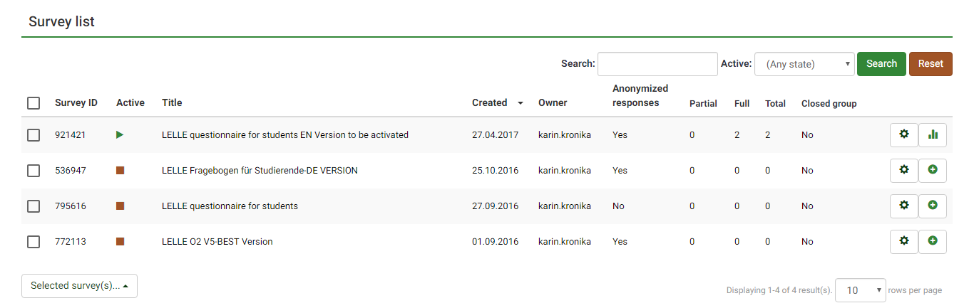

How to add participants

If you want to add participants to include in your survey, go to Surveys and choose the survey you want to work with (see previous step). Go to Create and click on Add participant.

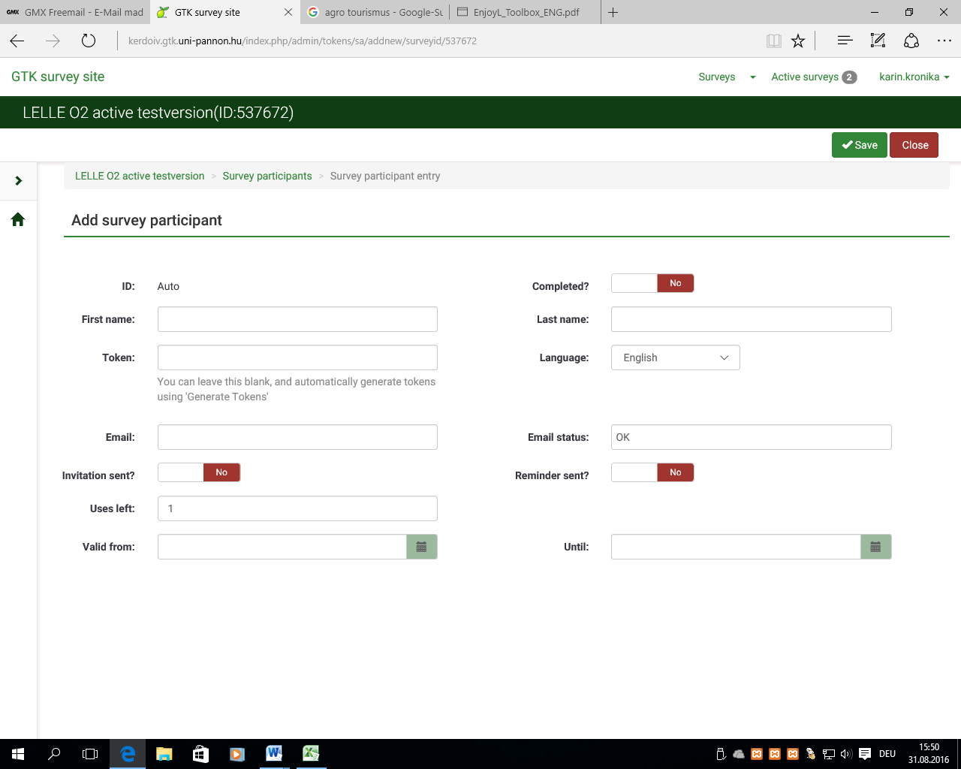
After this step, you can edit your settings for adding participants. Go to Save and Close the section.

How to edit participants

If you want to edit participants` settings, go to the survey you want to work with (see 1. step), click on Survey participants and choose the button Edit this survey participant on the left side of the row with the participant.

How to send invitations and reminders/copy link to share

If you plan to send invitations and reminders/copy link to share the questionnaire, choose the survey you want to work with, go to Survey participants and click on the button Inivitations & reminders. Choose between the options provided.

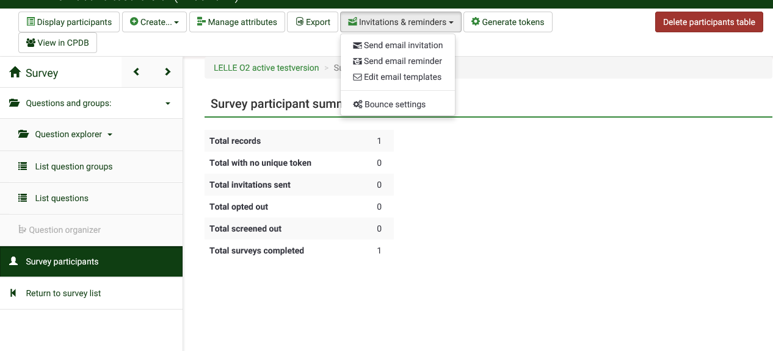
For sharing the link to the survey, simply click on the survey you plan to share (see 1. Step). You will the Survey summary including the Survey URLs.Copy the link to want to share.

How to view results: view/statistics/export in the Profiling criteria

To view the results in the Profiling criteria Survey, go to the survey you want to work with (see 1. step), go to Display participants and click on the button on the left in the row of the participant to view the response details.

Below you see the administrator`s view on details of survey responses, i.e. if the participant completed the survey. On the top of the page, you see the button to view statistics.

If you want to view the statistics of the survey, there are several options on the top of the page. Below you see the setting for the Expert mode. Alternatively, you can switch to Simple mode. By switching View summary of all available fields to On in the box on the left, you get an overview of the statistical illustration of responses (see following side).

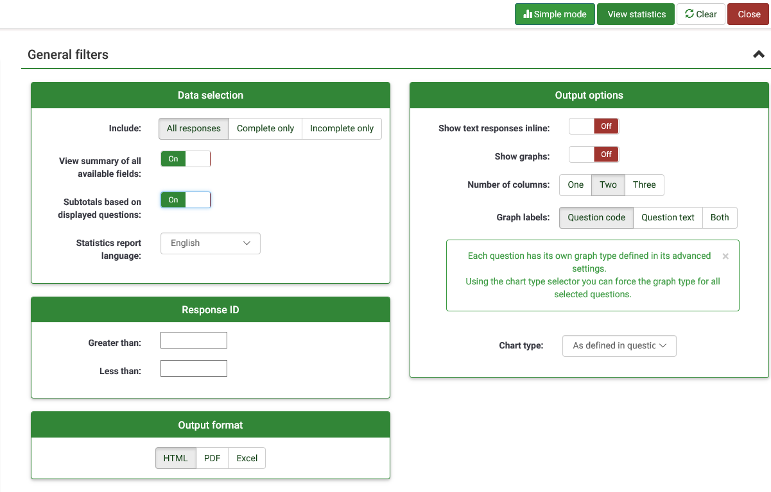

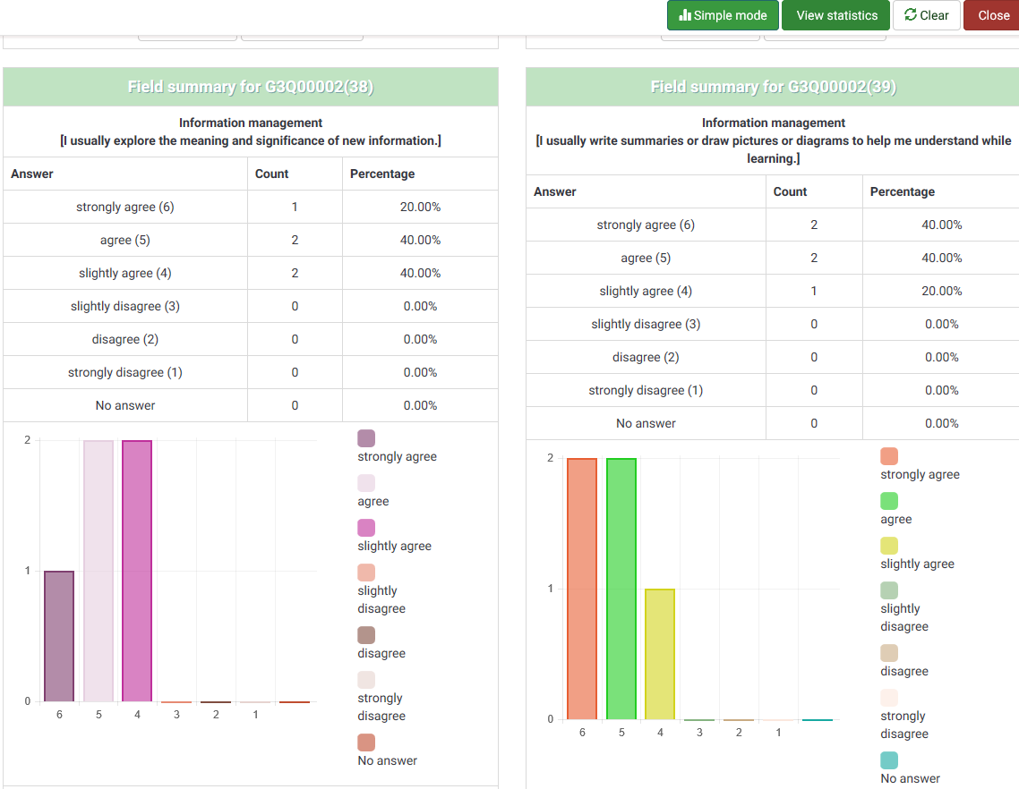

How to export results

To export of results, go to the survey you work with, click on Display/Export and choose the format you want to export the data.

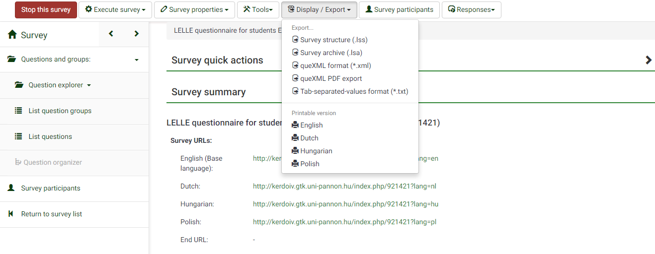

If you want to export i.e. in pdf. format, you have several setting options to define the display of the data in pdf. format.

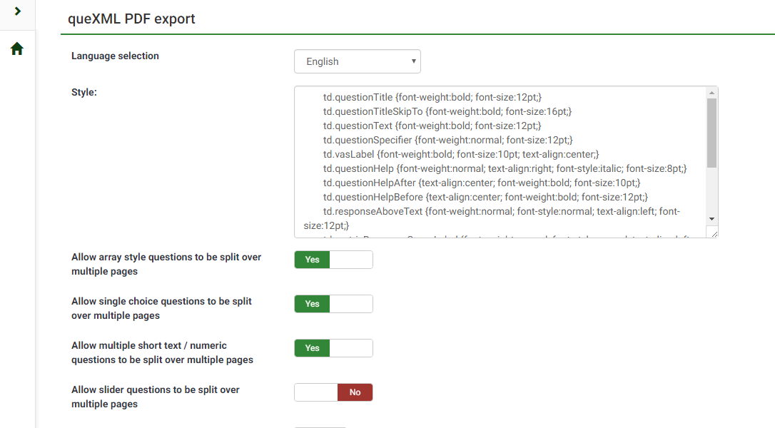

5. Appendices

Appendix Page

Appendix 0: HANDOUT - Summary of IO1 Methods to Develop / Evaluate Core Skills 49
Appendix 1: Critical Thinking Skill-Set 57
Appendix 2: Decision-making Case Scenario 58
Appendix 3: Public Health Case Scenario 59
Appendix 4: The Scientist 60
Appendix 5: The Professor 61
Appendix 6: Critical Thinking Scoring Rubric 63
Appendix 7: Seven Steps in Problem Solving 65
Appendix 8: The Deli Dilemma 66
Appendix 9: Teamwork Skills Self Inventory 67
Appendix 10: Problem Solving Organiser 68
Appendix 11: Problem Solving Scenario I 69
Appendix 12: Problem Solving Scenario II 70
Appendix 13: Problem Solving Score Rubric 72
Appendix 14: My Learning Portfolio 74
Appendix 15: Reflecting Questions 75
Appendix 16: Template for own notes on implementation of methods in your organisation 77
Appendix 17: Template for own notes on implementation of methods in your organisation 78
Appendix 18: Template for own implementation activity 79
Appendix 19: Short user manual of LELLE profiling tool for students 81
Appendix 20: Most often mentioned learning methods found during the project research phase 82

Appendix 0: HANDOUT - Summary of IO1 Methods to Develop / Evaluate Core Skills

 | Critical thinking | Problem solving | Managing own learning process
Methods | - Teamwork (includes as well: cooperation, giving feedback, careful listening, defend and pitch, collaborative reflection, etc.)  - Critical analysis (includes as well: written and oral analysis and presentation)  - Assertive communication (includes as well: raising questions, comments, presenting own ideas, discussions, etc.)  - Case study (includes as well: transferring knowledge to real life situations, exchange of good practices)  - Experiencing needs and limits and managing them  - Reflective learning  - Visualisation of a problem (includes as well: mindmap, charts, diagrams, etc.) | - Teamwork (includes as well: brainstorming, peer teaching, cooperation, giving feedback)  - Assertive communication (raising questions, comments, presenting own ideas, discussions)  - Visualisation of a problem (includes as well: Fishbone diagram, mindmap, charts, etc.)  - Case study (includes as well: transferring knowledge to real life situations, exchange of good practices)  - Critical analysis (includes as well: written and oral analysis and presentation, cost/benefit, value analysis, conflict analysis)  - Six thinking hats  - KAIZEN  - KANBAN  - 5S  - Role play  - Drama  - 5M  - Gamification  - Logical games  - Project thinking (includes as well: resource planning, usage of project management tools, environment analysis, stakeholder analysis, time management, etc.)  - Identifying common problems and looking for effective solutions | - Performance assessment system (includes as well: individual development plan, portfolio, etc.)  - Training courses  - Self-evaluation  - Peer-observation and feedback  - Comparison of self-evaluation results (from currect period and previous ones)  - Forcing/giving constrains (ex. deadlines)  - Cause – effect analysis (includes as well: strategic thinking,  - Visualisation (includes as well: charts, diagrams, modelling, etc.)  - Pro-active planning (includes as well: setting goals, learning paths)  - Case study (includes as well: transferring knowledge to real life situations, exchange of good practices)  - Time management
Evaluation | - Peer observation  - Feedback (from various people)  - Transferring knowledge to real life situations  - Process/pattern following  - Creativity  - Self-evaluation  - Collaborative reflection  - Usage of theory in proposed practical solutions  - Comparing prepared solutions within a group  - Evaluation cycle  - Taking into consideration of non-measurable factors  - Progress evaluation (includes as well: own progress evaluation)

Other ideas (not in the specific field related to the improvement of skills or relevant to all of the three skills):

- Idea box
- Focus on self-knowledge, self-recognition
- Strengthening of the self-confidence and the own responsibility
- “On the job training”: e. g. Placing the employee into another agency to learn the best practices
- Assessment centre
- Self-branding
- Real situations, own experience
- Conflict solving, managing
- Energizing (how did you feel, what did you learn, how can u use it?)
- Mentoring (e.g., student offered courses)
- Facilitate instead of “teaching”
- Student-centred learning process
- Workshops
- One-to-one talks
- Methods to increase concentration
- Working groups in debates, seminars, presentations followed by feedback
- Assigning new tasks
- Presenting various solutions to one problem
- Supervision and assistance
- Systematic monitoring of progress
- Learn from mistakes

Appendix 1: Critical Thinking Skill-Set

Basic Skill-Set
- Brainstorm | Brainstorm is an elementary and an effective way to get started to think critically:  - Brainstorm to generate ideas  - Ask questions about ideas
- Classify and Categorise | Classify and categorise involves asking questions and applying rules:  - Identify idea/ information/ object and sort it into a category  - Think about which idea/ information/ object go where and why
- Compare and Contrast | Examine closely each idea/information/ object:  - Think about the significance of each one: special features/ characteristics/ or potentials/ opportunities  - Look for similarities and differences
- Make Connections | See connections and make association:  - Make connections to real-life situations  - Identify patterns between and across ideas/ information
Guided Reasoning Skill-Set
- Evaluate information/ observation | Review given information:  - Question the given information/ observations/ conclusion  - Separate relevant from irrelevant information  - Distinguish between data, facts, opinions and arguments
- Explore alternative explanations | Explore other possible explanations:  - Provide alternative interpretations for information/ observations/ conclusions that could have several possible interpretations
- Identify additional information/ evidence | Source for more information/ evidence  - Identify additional information or evidence needed to evaluate the alternative interpretations

Appendix 2: Decision-making Case Scenario

You have started a new job in a town about 25 kilometres from where you live. It takes about an hour with public transportation (a local train and bus) and an about 20 minutes’ drive. You are contemplating of buying a car but you have several factors to consider before reaching a decision. Use a mind map to visualise your thinking process.

Mind map your decision:
Step 1: Put the main issue in the centre of the page to focus attention and to draw association.
Step 2: Explore main issue by adding branches to the map with key words to trigger connections and to recall more information.
Step 3: Colour code the branches and add images (optional).

Tips: Brainstorm all the information on public transportation network, road condition, cost for public transport and car etc., and weigh all the pros and cons,.

Transportation
Car
Public Transport

Appendix 3: Public Health Case Scenario

“But my dad had the vaccine and still got the flu”

The Issue:
1. Does this statement strongly support the idea that flu vaccines are not effective?

2. What are some alternative explanations for Dad getting the flu, besides that flu vaccine is not generally effective?

3. What other information would you need in order to support or oppose the different explanations?

Note: For peer evaluation: 3 = Good; 2 = Average; 1 = Below Average Score:______

Appendix 4: The Scientist

A scientist working in a government agency believes that an ingredient commonly used in bread causes criminal behaviour. To support the hypothesis, the scientist notes the following evidence:
99% of criminals consumed bread prior to the criminal activity.
Crime rates are extremely low in areas where bread is not consumed.

The Issue
1. Do the data strongly support the hypothesis?

2. Are there other explanations for the data besides the scientist’s hypothesis? If so, describe

3. What kind of additional information or evidence would support or oppose the scientist’s hypothesis?

Appendix 5: The Professor

A certain professor in a local university conducted a study on the effect of movies on teenagers below the age of 18.
The professor hired several dozens of researchers to conduct questionnaire survey outside 30 different cinemas, targeting youths of the age of 13 to 17. The study lasted 4 weeks, and was carried out during office hours of Monday to Friday. A total 7,600 youths were involved. The study found out that the favourite movies genre for over 60 % of the interviewees were action movies. And in those who liked action movies – accounting for 80% of all interviewed youths – 16 % has criminal records; on the contrary, only 2% out of the remaining 20 % of youths who disliked action movies have criminal records. Also, those who liked action movies are on average less well-educated. As per the above data, the professor reached this conclusion: for youths, action movies are not only a disincentive for school studies, but also promote criminal tendencies. Based on the study, the professor suggested the government to tighten the grading of action movies; otherwise social ethics will deteriorate.

The Issue:
1a. Comment in detail the research methods of the professor.

1b. Do the data strongly support the findings and conclusion drawn?

2a. Are there other explanations for the data? If so, describe.

2b. Is there room for improvement in the professor’s research methods? If so, how will you improve the professor’s research methods?

3a.What kind of additional information or evidence would support or oppose the professor’s findings?

3b. Do you think the government should legislate to tighten the grading of action movies according to the results of the professor’s study? Why?

Appendix 6: Critical Thinking Scoring Rubric

Name of Participant: |  | Activity No:
Name of Evaluator: |  | Total Score:

Rating Criteria | NA | Rating Scale
 |  | Emerging |  | Developing |  | Mastering
Summarise problem or issue |  | Unable to identify and  summarise issue accurately; missing some core aspects. |  | Summarises issue and identifies some core aspects, though not quite clear at times. |  | Clearly summarises the issue and identifies subsidiary or implicit aspects of the issue.
 |  | 1 | 2 | 3 | 4 | 5 | 6
Brainstorm & ask questions |  | Brainstorms takes place randomly with no relevant questions on the given information. |  | Brainstorms and asks adequate questions but did not extensively explore ideas nor goes beyond given information. |  | Brainstorms and asks good questions to explore ideas and goes beyond given information.
 |  | 1 | 2 | 3 | 4 | 5 | 6
Classify & categorise |  | Classifies and categorises information, idea or objects randomly with no clear set of criteria or rules. |  | Classifies and categorises information, idea or objects with a set of criteria or rules, but ambiguous at times. |  | Classifies and categorises information, idea or objects with a set of clearly defined criteria or rules.
 |  | 1 | 2 | 3 | 4 | 5 | 6
Compare & contrast |  | Identifies similarities and differences in information and arguments with few accuracies and surface reasoning. |  | Identifies similarities and differences in information and arguments accurately most of the time with sufficient reasoning. |  | Identifies similarities and differences in information and arguments very accurately and with deep reasoning.
 |  | 1 | 2 | 3 | 4 | 5 | 6
Make connections |  | Identifies some patterns between and across ideas/ information but unable to make sound connections nor draw valid conclusions. |  | Identifies patterns between and across ideas/ information. Able to make some connections though conclusions made are not always justified. |  | Identifies patterns between and across ideas/ information. Able to make connections appropriately and draw sound conclusions.
 |  | 1 | 2 | 3 | 4 | 5 | 6
Evaluate information/ observation |  | Lacks skills in evaluating information source.  Repeats information with no or only few questions. Unable to discern fact from opinion most of the time. |  | Displays adequate skills in evaluating information  source. Able to separate relevant from irrelevant information. Use of evidence is selective, discerns fact from opinion but not always accurate. |  | Displays good skills in evaluating information source. Able to separate relevant from irrelevant information. Examines  evidence and questions accuracy and relevance. Discerns fact from opinion accurately.
 |  | 1 | 2 | 3 | 4 | 5 | 6

Explore alternative explanations |  | Attempts to explore alternative explanations but tends to adopt explanations with little question. Unable to interpret these alternative explanations in relation to situation and context. |  | Addresses alternative explanations but sources are limited. Does not always interpret these alternative explanations accurately in relation to situation and context. |  | Addresses diverse alternative explanations from a variety of sources to qualify analysis. Able to accurately interpret these alternative explanations in relation to situation and context.
 |  | 1 | 2 | 3 | 4 | 5 | 6
Identify additional information and evidence |  | Ignores or superficially evaluates obvious alternative explanations.  Unable to identify additional information and evidence to integrate alternative explanations. Shows superficial understanding of situation and context. |  | Offers analyses and evaluations of alternative explanations. Able to identify some additional information and evidence to integrate alternative explanations. Reflects sufficient understanding of the situation and context. |  | Thoughtfully analyses and evaluates major competing explanations. Identifies accurately the additional information and evidence to qualify these competing explanations. Effective integration and use of alternative explanations. Reflects an in-depth understanding of the situation and context.
 |  | 1 | 2 | 3 | 4 | 5 | 6
Sub-score
Total Score

Appendix 7: Seven Steps in Problem Solving

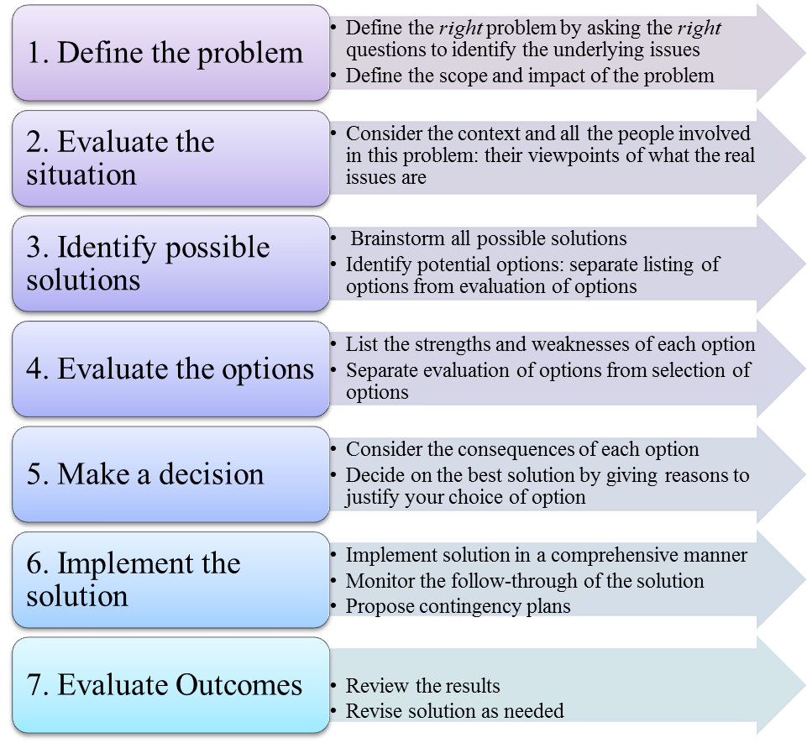

Appendix 8: The Deli Dilemma

You work in a deli located in a convention centre. This building is about 20 minutes’ walk from most office buildings. Not many office workers come to your deli owing to the walking distance and expensive parking fees at the convention centre. Business is good only on days when there are events held in the convention centre. How can you improve your business? You may use other resources to gather all relevant information to find solutions to this problem.

1. Define the Problem |  | 4. Evaluate the Solutions
 |  | Pros |  | Cons
2. Evaluate the Situation |  | 5. Make a Decision
 |  | Option |  | Reasons
3. Identify all Solutions |  | 6. Implement Solution
7. Evaluate the Outcome
What went well? | What did not go well? |  | What could have been done better?

Appendix 9: Teamwork Skills Self Inventory

Skills are learned behaviours and abilities. There are many different types of skills that are relevant to career development. Effective teamwork skills are very important. What do you think makes a good team member? Do you have the teamwork skills it takes to be a good team member? Take this self-inventory rating your strengths and areas you would like to improve upon. Check the box that matches how you rate each skill. Finally, list ways you can strengthen the skills in the ‘needs improvement’ column.

Skill | Strong | Average | Needs Improvement
Willing to Listen – you listen to and respect various points of view
Self-Motivated – you are responsible and dedicated to completing the task at hand
Honest – you are fair and willing to share openly with others

Reliable and Trustworthy – you can be counted on

Effective Communicator – you clearly express your thoughts and ideas

Organised – you are prepared and ready to participate and contribute

Cooperative – you enjoy working with other team members to reach a common goal

Flexible – you embrace change and aren’t afraid to try new things

Problem Solver – you can identify the issue and find a solution

Appendix 10: Problem Solving Organiser

1. Define the Problem |  | 4. Evaluate the Solutions
 |  | Pros |  | Cons
2. Evaluate the Situation |  | 5. Make a Decision
 |  | Option |  | Reasons
3. Identify all Solutions |  | 6. Implement Solution
7. Evaluate the Outcome
What went well? | What did not go well? |  | What could have been done better?

Appendix 11: Problem Solving Scenario I

Here is a list of suggested workplace scenarios. Each small group to choose a scenario, act out and work through as a team. The team should come up with potential solutions to solve the problem behaviour using the organiser which contains the seven-steps in problem solving.

Scenario 1: The leader of the team wants to do everything himself or herself. He/ She has a very big ego and is difficult to work with.

Scenario 2: One team member is extremely shy. However, he or she has the most expertise and background to help solve the technical issue your team is experiencing in your best product.

Scenario 3: Two of your team members do not get along. There are many hard feelings between the two and they refuse to communicate with one another.

Scenario 4: One of your team members is very social. In fact, he or she believes they are the life of the party. This team member enjoys telling jokes continually which derails the conversation.

Scenario 5: One team member is very sensitive and emotional. This member gets upset when he/ she doesn’t feel listened to and is extremely offended if all of his or her ideas do not get used. To further complicate matters, most of this team member’s ideas are not practical.

Scenario 6: One of your team members enjoys hearing himself/ herself talk. He/ she dominates the discussion and expects everyone to listen to them. This person is not the assigned leader of the problem solving team.

Scenario 7: You are a team of four on a project. All four of you report to the same team leader. Two of your members do not contribute to the project effort, only you and one other teammate have been doing all the work.

Appendix 12: Problem Solving Scenario II

Choose one of the three scenarios listed below. Complete the seven-step problem solving process for one of the scenarios by writing your answers on graphic organiser.

Scenario 1
Tom, one of your employees, has worked in the office for ten years. He is well liked and knowledgeable about the history of the office and University systems. There is no past history of performance issues that you can see from looking at past performance reviews. What you have observed is that Tom regularly shows up late, (office opens at 8:30am, Tom usually comes by 9/9:15am), takes longer than an hour for lunch, and often is heading out the door by 4:30pm (office closes at 5pm). You notice that this type of behavior seems to happen once in a while for other employees in the office, but seems like a daily practice for Tom. He never records any of this time on his time card as official time off.
Take a few moments to think about the situation and make some notes. What would you do? What would be your first step?

Scenario 2
You have been promoted to the position of manager of the department. You’ve worked together with most of your direct reports for many years. As a peer, you have had good working relationships with everyone in the area. At least one of your peers also applied for the manager position. Because of the department’s relatively flat organizational structure, employees have not had many opportunities for promotion. Most of the employees have worked in the same area for most of their work history. As you are settling in to your new role, you feel that some of your former peers, Sydney and Alex, are not taking you seriously as the new supervisor. You have given some directions about how you want certain projects handled, only to see some of the staff ignore you and complete the projects in other ways. When you have addressed this, they both have given reasons such as, “The old way is better,” “What’s the big deal?” and “With the equipment we have, we had to do it that way.”
Take a few moments to think about the situation and make some notes. What would you do? What would be your first step?

Scenario 3
You have been newly hired into you supervisory role. You have six direct reports. Three have worked for the University less than five years; the other three have more than ten years in the department. Overall, you have been impressed with the staff’s dedication to serving the department’s administrative needs and responding to requests from professors and students. However, you have observed that one of the long time staff members, Marie, seems to take a long time with any of her assignments and is avoided by most of the students and professors requesting services. Her behavior strikes you as unwelcoming and you have overheard her raise her voice a few times. When you bring up the issue with your boss, Noah, he says Marie gets the job done and is known for being hard to work with. This has been a long standing issue and the last supervisor did little to change the situation. Noah is also new to his role and wants to have a high performing office. Noah wants you to address Marie’s behavior.
Take a few moments to think about the situation and make some notes. What would you do? What would be your first step?

Appendix 13: Problem Solving Scoring Rubric

Name of Participant: |  | Activity No:
Name of Evaluator: |  | Total Score:

Rating Criteria | NA | Rating Scale
 |  | Emerging |  | Developing |  | Mastering
 |  | 1 | 2 | 3 | 4 | 5 | 6
Define the problem |  | Defines the problem at a superficial level with no or few evidences of the relevant underlying issues displaying surface knowledge of the scope and impact of the problem. |  | Defines the problem with evidence of most of the relevant underlying issues displaying adequate knowledge of the scope and impact of the problem. |  | Defines the problem succinctly with evidence of all relevant underlying issues displaying in-depth knowledge of the scope and impact of the problem.
 |  | 1 | 2 | 3 | 4 | 5 | 6
Evaluate the situation |  | Collects information/ data of the context and people involved in the problem using insufficient sources resulting in limited data and information.  Able to isolate only a few of the variables that influence the problem, and shows incoherent description of how each variable influence the problem. |  | Collects information/ data of the context and people involved in the problem using sufficient sources. Able to isolate most of the variables that influence the problem, but not quite accurate in the description of how each variable influence the problem. |  | Collects information/ data of the context and people involved in the problem using rich range of sources. Able to isolate all the variables that influence the problem and accurately describe the influence of each on the problem.
 |  | 1 | 2 | 3 | 4 | 5 | 6
Identify possible solutions |  | Proposes one or two solutions/ hypotheses  indicating a weak comprehension of the problem: solutions/ hypotheses superficially addresses to the contextual factors of the problem and people involved. |  | Proposes two or more potential solutions/ indicating adequate comprehension of the problem: solutions/ hypotheses are sensitive to most of the contextual factors of the problem and some people involved. |  | Proposes a number of potential solutions indicating a deep comprehension of the problem: solutions/ hypotheses are sensitive to all the contextual factors of the problem and the people involved.
 |  | 1 | 2 | 3 | 4 | 5 | 6
Evaluate the options |  | Identifies a few strengths and weaknesses with insufficient reasoning or reasoning errors. |  | Identifies most of the strengths and weaknesses of the potential option(s) with substantial reasoning in most instances. |  | Identifies all strengths and weaknesses of the potential options and demonstrates insightful reasoning.
 |  | 1 | 2 | 3 | 4 | 5 | 6
Make a decision |  | Identifies and discusses consequences of the potential option(s) but with little or superficial reference to the contextual factors. Examines feasibility of the potential option(s) and their impact at a superficial level. Decision on the best solution is not substantially justified. |  | Identifies and discusses consequences of the potential option(s) which consider most of the contextual factors. Examines feasibility of the potential option(s) and weighs their impact with adequate explanation for the best solution. |  | Identifies and discusses consequences of the potential options which consider all contextual factors. Thoroughly examines feasibility of the potential options and weighs impacts of each option to decide on the best solution with insightful explanation.
 |  | 1 | 2 | 3 | 4 | 5 | 6
Implement the solution |  | Implements the solution in a manner that addresses the problem statement but ignores relevant contextual factors. Does not provide a clear plan to monitor implementation and no corrective action if circumstances change. |  | Implements the solution in a manner that addresses most of the contextual factors of the problem. Provides a basic plan to monitor the implementation and to take corrective action if circumstances change. |  | Implements the solution in a manner that addresses thoroughly and deeply multiple contextual factors of the problem. Provides a comprehensive plan to monitor the implementation and to take corrective action if circumstances change.
 |  | 1 | 2 | 3 | 4 | 5 | 6
Evaluate the outcome |  | Reviews results in terms of the problem defined with no or little consideration of need for further work or a revised solution. |  | Reviews results relative to the problem defined with some consideration of need for further work or a revised solution. |  | Reviews results relative to the problem defined with thorough, specific considerations of need for further work or a revised solution.
 |  | 1 | 2 | 3 | 4 | 5 | 6
Communicate and present solution |  | Superficially defines problem statement and presents final choice of solution with few substantial arguments. Not able to respond to queries with valid reasoning. At times, shows uncertainty in one’s position. |  | Defines problem statement reasonably accurately and presents final choice of solution with some substantial arguments. Able to respond to queries with some sound reasoning, though at times shows ambiguity in restating one’s position |  | Succinctly defines problem statement and presents final choice of solution with very convincing arguments. Able to respond to queries with sound reasoning and defend one’s position confidently.
Sub-score
Total Score

Appendix 14: My Learning Portfolio

Name
Description of Core Skill
Activities | Reflective Summary | Evaluation
Self-evaluation / Self-knowledge:
- What new skills, techniques/ information have I learned that will be useful to me?
- What have I done well?
- What areas would I like to see improvement?

Appendix 15: Reflecting Questions

- Who are you? What describes you best?

- What are your individual characteristics (strengths, weaknesses, needs, etc.)?

- Set an individual learning goal:

- Why do you choose this one?

Determine the ways/strategy to reach your goal:
  - Where and how do you plan to learn?

  - How do you plan to organise your time?

  - Which learning techniques do you apply?

  - How do you track evidence? (Portfolio etc.)

  - Which difficulties might show up? How to deal with them?

Appendix 16: Template for own notes on implementation of methods in your organisation
 |  | Learning Competence in general | Critical Thinking | Problem Solving | Managing own learning process
Your organisation:

Appendix 17: Template for own notes on implementation of methods in your organisation

Method for evaluation of core skills | Individual | Peer | Group | Others

Appendix 18: Template for own implementation activity
LESSON OVERVIEW

In this lesson, participants will learn ………………………………………………………………………………………………………………………………………………………………………………………………………...

Lesson Objectives
After completing this lesson, participants will be able to:
- …………………………………………………………
- …………………………………………………………
- …………………………………………………………

Lesson Structure

Activity | Objective | Method | Estimated Duration
Starter |  | - …………………………. | .. min
Hands-on |  | - ………………………….  - ………………………….  - ………………………….  - …………………………. | .. min
Review |  | - ………………………….  - …………………………. | .. min

Activity ……..: ……………… – …………………………….

Purpose:
The purpose of this starter activity is to ….

………………………………………………………………………………………………………

………………………………………………………………………………………………………

………………………………………………………………………………………………………

………………………………………………………………………………………………………

Duration: … min

Material: …………………………………………………………………………………………..

Method: …………………………………………………………………………………………..

Facilitation Steps:

………………………………………………………………………………………………………

………………………………………………………………………………………………………

………………………………………………………………………………………………………

………………………………………………………………………………………………………

Appendix 19: Short user manual of LELLE profiling tool for students

When you finished the survey, you will see this final page. You have the possibility to Print your answers or to View the statistics for this survey.

If you want to print your answers, click on the related option on this final page. You will see the following:

You can export the data in pdf. format by clicking on the related button. Below you see the printable pdf. version

Appendix 20: Most often mentioned learning methods found during the project research phase
Based on the activation of learners’ learning responsibilities, the most often mentioned learning methods found during the project research phase (presented in IO1) are summarised in the table below:
Critical thinking | Problem solving | Managing learning process
- Discussions  - Meetings  - Giving feedback  - Communication / assertive communication  - Raising questions, comments  - Peer supervision and support  - Workshops / trainings  - Teamwork  - Critical analysis | - Teamwork / group work  - Workshops  - Discussions  - Presenting own ideas and implementing them  - Idea box  - Presentation / presenting  - Feedback | - Individual development plan (sometimes linked to performance assessment system)  - Self-evaluation / Self-knowledge  - Career orientation/planning  - Comparison of self-evaluation results (from current period and previous ones)  - Forcing/giving constrains (deadlines, etc.)  - Training courses (outsourced)  - Feedback & reward (sometimes annual performance report & feedback)  - Learning portfolios for tracking evidences of one’s own learning  - Peer-observation and feedback

6. References

Cedefop. (2011a). Briefing note: When defining learning outcomes in curricula, every learner matters. Thessaloniki: European Centre for the Development of Vocational Training (Cedefop).
http://www.cedefop.europa.eu/EN/Files/9060_en.pdf

Critical Thinking Assessment Test. Tennessee Technological University for the NSF-funded Critical Thinking Assessment Test (CAT) project. Retrieved from https://www.tntech.edu/cat

RealCareer (2015). Effective Employability Skills. USA: Realityworks Inc.

European Commission, (20.11.2012). Rethinking Education: Investing in skills for better socio-economic outcomes. COMMISSION STAFF WORKING DOCUMENT. Supporting the Teaching Professions for Better Learning Outcomes. Strasbourg, European Commission. Brussels
http://eur-lex.europa.eu/legal-content/EN/ALL/?uri=CELEX:52012DC0669

European Commission, (November, 2012). Education and Training 2020 Work programme. Thematic Working Group 'Assessment of Key Competences' Literature review, Glossary and examples. Brussels
http://ec.europa.eu/dgs/education_culture/repository/education/policy/school/doc/keyreview_en.pdf

European Communities, (2007) KEY COMPETENCES FOR LIFELONG LEARNING. European Reference Framework. Luxembourg.
https://www.erasmusplus.org.uk/file/272/download

EUROPEAN COMMISSION (14.03.2008) EDUCATION AND TRAINING 2010 WORK PROGRAMME, Cluster Key Competences – Curriculum Reform. Synthesis Report on Peer Learning Activities in 2007. EUROPEAN COMMISSION Directorate-General for Education and Culture
http://ec.europa.eu/dgs/education_culture/repository/education/policy/school/doc/peer07_en.pdf

Raymond J. Wlodkowski (2003): The Motivational Framework for Culturally Responsive Teaching is presented as a guide to foster participation, learning, and transfer throughout a professional development program for all participants.
Source: New Directions for Adult and Continuing Education, no. 98, Summer 2003, Wiley. Fostering Motivation in Professional Development Programs
http://raymondwlodkowski.com/Materials/Fostering%20Motivation%20in%20Professional%20Development%20Programs.pdf?utm_campaign=elearningindustry.com&utm_source=%2F17-tips-to-motivate-adult-learners&utm_medium=link

Snyder, L. G., & Snyder, M. J. (2008). Teaching critical thinking and problem solving skills. The Journal of Research in Business Education, 50(2), 90.

Ku, K., Hau, K-T., Ho, I. (2011). The Learning and Teaching of Critical Thinking Skills: Scenario Analysis. Hong Kong: Education Bureau of the Government of the HKSAR.

Workplace Learning and Development (WLD). University of Massachusetts Amherst. Retrieved from https://www.umass.edu/wld/

Excerpted with permission from Assessing Outcomes and Improving Achievement: Tips and tools for Using Rubrics, edited by Terrel L. Rhodes. Copyright 2010 by the Association of American Colleges and Universities.

Decision Making Rubric. Retrieved from http://usm.maine.edu/sites/default/files/assessment/Rubric-DecisionMaking.pdf

Critical Thinking Scoring Rubric. Retrieved from http://www.eiu.edu/learninggoals/pdfs/KansasStUni-CriticalThinkingRubric.pdf

Web: http://lelle.gtk.uni-pannon.hu www.facebook.com/lelleproject www.linkedin.com/groups/8537515

LELLE: Let's learn how to learn! - Raising awareness to the importance of and providing an innovative solution for the inclusion of the training of learning skills in existing higher education curricula
This
This project (n° 2015-1-HU01-KA203-013619) has been funded with support from the European Commission. This publication reflects the views only of the author(s), and the Commission cannot be held responsible for any use which may be made of the information contained therein.

European Communities, (2007) KEY COMPETENCES FOR LIFELONG LEARNING. European Reference Framework. Luxembourg
European Communities, (2007) KEY COMPETENCES FOR LIFELONG LEARNING. European Reference Framework. Luxembourg; p. 8.
Higher Education
Rethinking Education: Investing in skills for better socio-economic outcomes. COMMISSION STAFF WORKING DOCUMENT. Supporting the Teaching Professions for Better Learning Outcomes. Strasbourg, European Commission. 2012. p. 5
Rethinking Education: Investing in skills for better socio-economic outcomes. COMMISSION STAFF WORKING DOCUMENT. Supporting the Teaching Professions for Better Learning Outcomes. Strasbourg, European Commission. 2012. p. 15
“However, the following countries have defined the competences that teachers require, in greater or lesser detail: Austria, Belgium (Flemish Community), Estonia, Germany, Hungary, Ireland, Luxembourg, the Netherlands, Poland, Slovenia and the United Kingdom.” Rethinking Education: Investing in skills for better socio-economic outcomes. COMMISSION STAFF WORKING DOCUMENT. Supporting the Teaching Professions for Better Learning Outcomes. Strasbourg, European Commission. 2012. p. 23
Cedefop. (2011a). Briefing note: When defining learning outcomes in curricula, every learner matters. Thessaloniki: European Centre for the Development of Vocational Training (Cedefop); p. 13
Available end of the project on the project website
Within the LELLE project we are aiming at university students in their first study year
“Reforms need to be theoretically well grounded, evidence-based, and pragmatic. A holistic vision is needed including the whole lifelong learning provision. A systemic approach requires that all elements, such as curricula, teacher education (initial and in-service) and professional development, pupil assessment, etc. are addressed” .EDUCATION AND TRAINING 2010 WORK PROGRAMME, Cluster Key Competences – Curriculum Reform. Synthesis Report on Peer Learning Activities in 2007, p. 10f
EDUCATION AND TRAINING 2010 WORK PROGRAMME, Cluster Key Competences – Curriculum Reform. Synthesis Report on Peer Learning Activities in 2007
EDUCATION AND TRAINING 2010 WORK PROGRAMME, Cluster Key Competences – Curriculum Reform. Synthesis Report on Peer Learning Activities in 2007, p. 8f
NB: allocation to the project’s core skills is only based on the LELLE survey participants’ replies
Material for purchase

